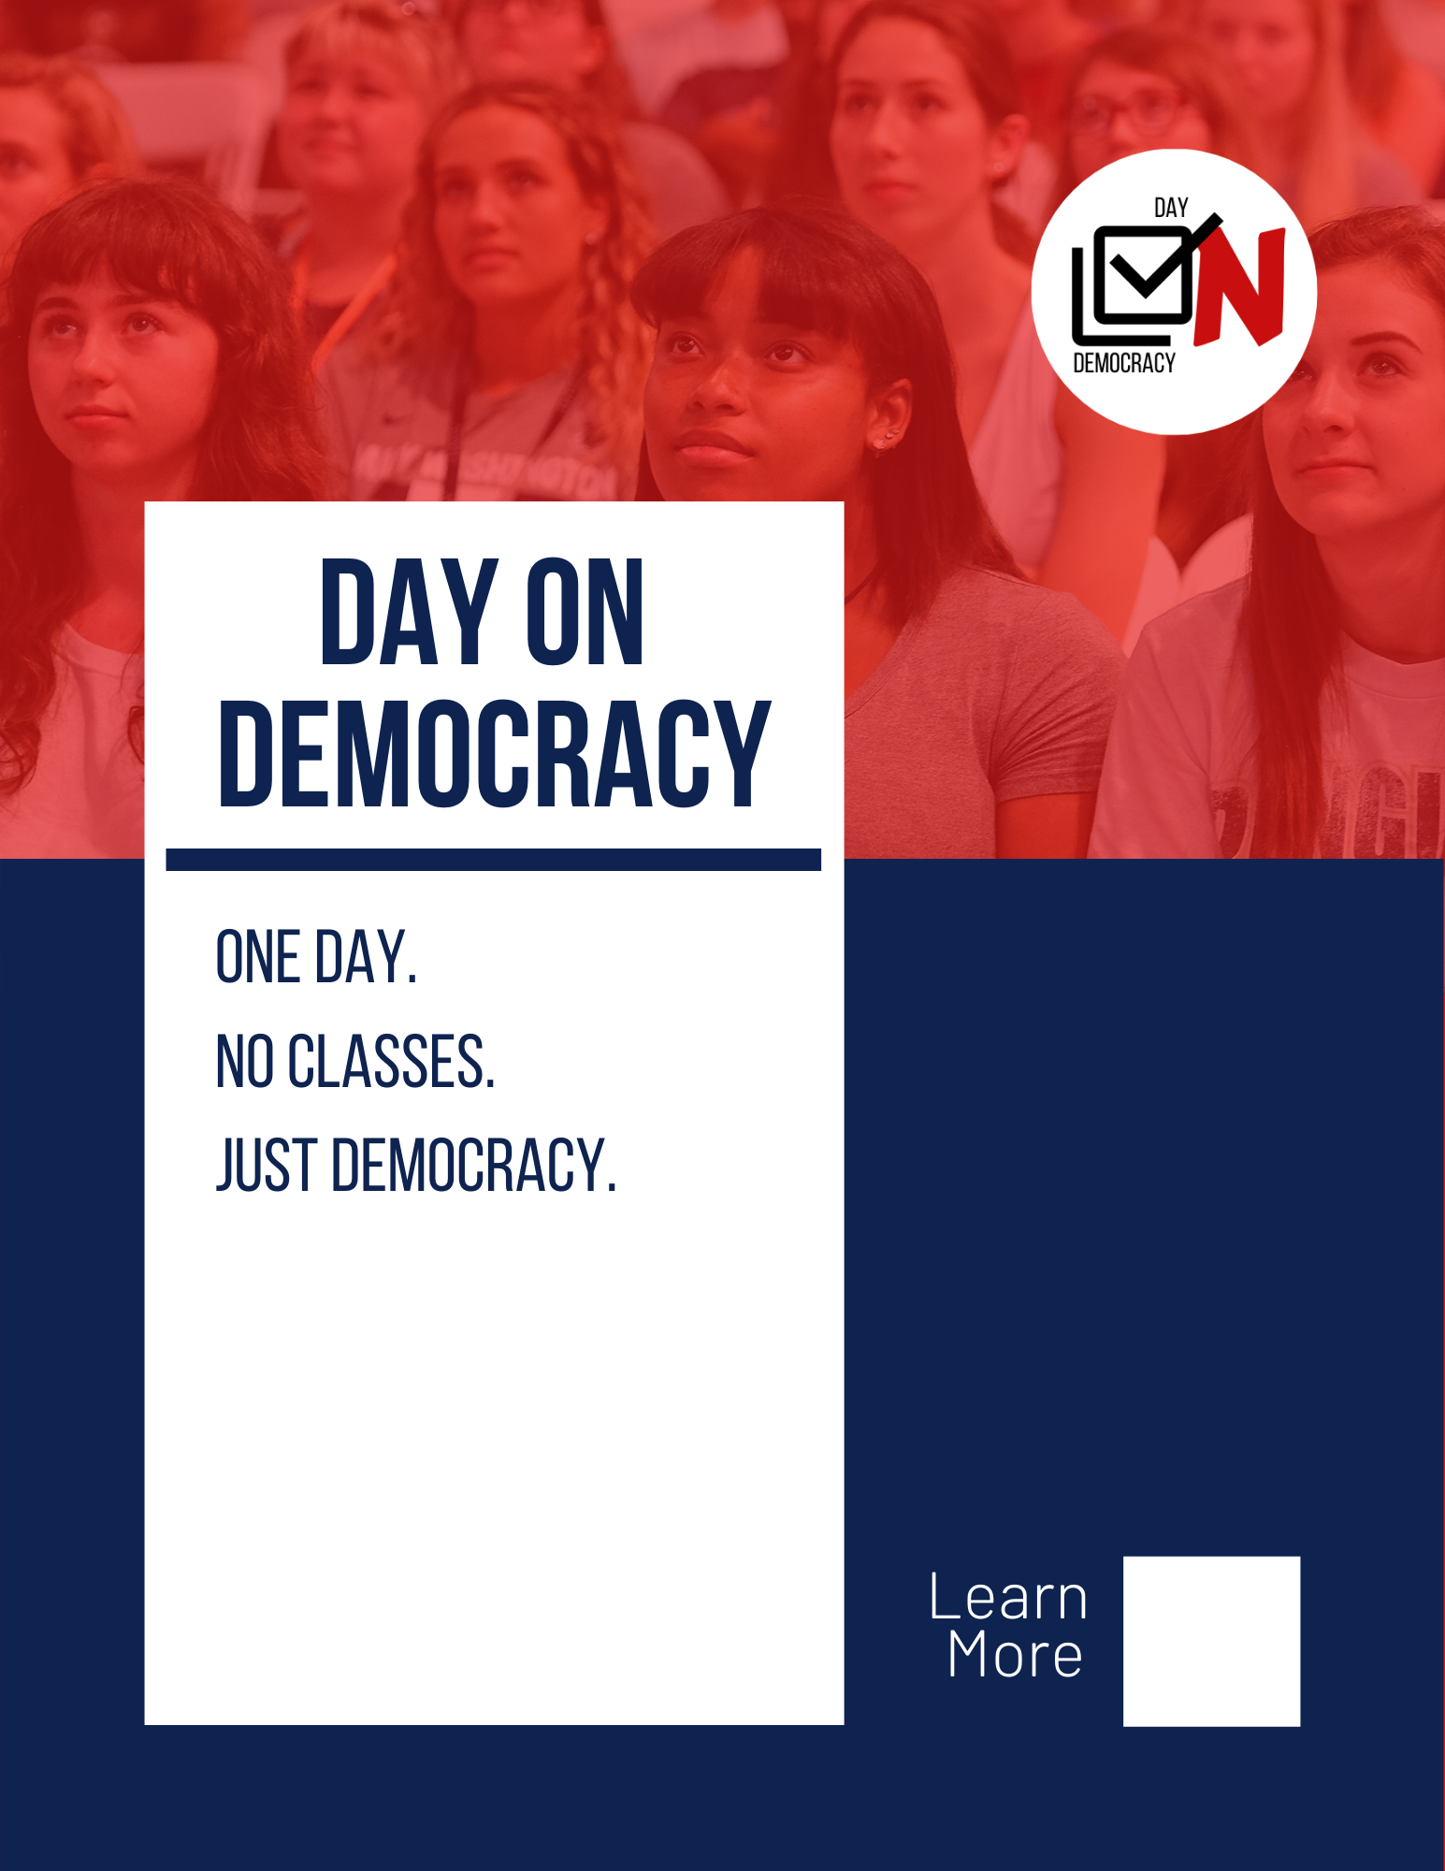

DATE

Presented for consideration by the [University of XYZ]

Authored by: Your Name

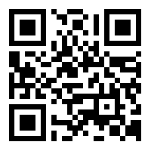

Table of Contents

Executive Summary 2

On This Proposal 3

Strategic Vision 3

Purpose 3

What is Day on Democracy? 4

Introduction 4

Implementation 5

Alignment with Our University Values 5

FAQ 6

References 8

Executive Summary
This formal motion for the legislative body of [your school’s name] calls for the adoption of the Day on Democracy program. The strategic vision and recommended implementation of the Day follow in this proposal. Day on Democracy calls generally for 1) increased civic engagement and student-community engagement in the months leading up to election day and 2) a Day on Democracy on Election Day, organized and facilitated by the school. Day on Democracy specifically recommends the cancellation of classes on Election Day to this end.

On This Proposal [optional]
[Labor of Love

While not completely necessary, this section is an opportunity for your team to detail the inspiration that brought your institution’s proposal to life. While we’ve provided the groundwork for this proposal, the Day would not be possible without your hard work and tenacity. This is your chance to appreciate the work that went into your proposal either by giving special thanks, making mention of civic engagement already present on campus, or anything else you deem fitting. Personalize it. Remember that this is your proposal- your democracy.

Best,
Day on Democracy Team ]

Strategic Vision

Purpose

The purpose of Day on Democracy is to promote democratic participation in students, faculty, and community members, especially those without the means or know-how to be involved in politics. Implementation of the Day is built around three guiding goals:

Increasing Voter Turnout and Political Engagement
Many who wish to work on political campaigns, work the polls, or just vote in general are usually unable to do so without incurring the penalty of missing classes. his goes for both students and faculty alike. Commuters especially have a difficult time finding the time to vote (Newman, Johnson, and Lown 2013). At our school, [insert NSLVE data here. The NSLVE is a non-partisan ongoing research study which reports civic engagement and voter turnout data about most Higher-Ed institutions in the U.S. Proposals like this always benefit from the usage of hard evidence. The most recent data can be found at https://idhe.tufts.edu/2018data.]

Incentivizing Community Engagement and Civic Service
The opportunities for community engagement and civic service that Day on Democracy provides bolster a service-oriented campus culture. Providing and incentivizing experiences like the Day motivates students to value community engagement and civic service both now and in their futures as U.S. citizens (Thomas, Nancy, Inger Bergom, Ishara Casellas Connors, Prabhat Gautam, Adam Gismondi, and Alena Roshko 2017). Additionally, strengthening the relationship between the community and [your institution] gives community stakeholders a chance to view [your institution] as a valuable institution and partner (Massey, Field, and Chan 2014).

Creating A More Well-Rounded College Experience
Day on Democracy gets students out of their comfort zone and into their democracy. When our university encourages students to use their voices, the campus environment exudes trust over partisanship and service over apathy. We believe that this kind of environment is a necessary part of promoting a well-rounded college experience (Jacoby 2009).

What is Day on Democracy?

Introduction

Day on Democracy proposes that all classes will be canceled on Election Day on each November General Election. The university itself would be open, but classes would not be held. Some institutions may be unable to guarantee this for all types of classes (i.e., lab courses or once per week lectures) and compromise may be necessary for your institution. Please see Class Cancelling Logistics on the next page for more on this. The projected date of the First Day on Democracy is [date of next election].

Day on Democracy takes a multi-faceted approach to educating, inspiring, and engaging students outside of the lecture hall. The program consists of three stages:

- Registration. From August to September, the university focuses on registering incoming freshmen and transfer students. Registration opportunities should be presented in orientation events, first-year classes (where applicable), and throughout the first week of classes.
- Education. During the month of October, the university may host guest speakers, debates, and town halls. This month focuses on holding events that feature information on the processes of elections, the candidates running in local districts, and the upcoming Day on Democracy.
- Celebration. The program culminates with the Day. On Election Day in November, classes are canceled and replaced with volunteer opportunities, get-out-the-vote activities, and celebratory social events. On this Day, students will move out of the classroom and into the streets, engaging with the surrounding community.

Implementation

[Out of all the sections, this one is most reliant on your work because it specifically concerns your bureaucracy. The motivation for this section is based in experience: the motion which was passed at our own university did not include any provisions for implementation guidelines or strategy, and the project sat in bureaucratic hell for an entire semester. Here’s what we would have written, had we had the foresight- note the important inclusion of student leadership:]

Given the scale of the Day, it will require frequent and open communication between faculty-at-large, the Center for Community Engagement, the Honors Program, the First-Year Experience Program and students to be impactful and successful. We thus recommend the establishment of a working group co-chaired by one student, one faculty member, and one administrator with at least one other representative from each aforementioned group. The value of the student co-chair is twofold: 1) it ensures that students are fully involved with and well-represented in the evolution of the Day, and 2) it allows the University to apply for student-initiative grants to supplement funding for the Day. This working group will be initially tasked with grant applications, coordinating faculty-led incentives for student participation, and coordinating various Election Day events.

Alignment with Our University Values

Day on Democracy is entirely consistent with [your institution]’s community values.
[This will require that you do research on YOUR institution’s values. Values that already incorporate civic engagement will be easier to connect to the aims of the Day, but other institutions may find it difficult to find immediate incentives to adopt the Day. Here are how we aligned the proposal with UMW value:]

Service and Civic Engagement
Farmer Multicultural Center, Center for Community Engagement, and Office of Student Activities and Engagement will collaborate to create civic engagement opportunities for students. Their efforts will include increased coordination with community partners and organizations.

Opportunity and Stewardship
The proposal provides a variety of high-impact learning opportunities anchored in
civic engagement. Students will benefit from informed participation in the
American political process and interactions with community groups.

Diversity/ Inclusion
Through the Day on Democracy, Mary Washington can champion a politics that is
civil, inclusive, and evidence-based. Educating for democracy requires a recognition
that political and partisan are not interchangeable. It is possible and necessary for
the University to foster constructive dialogue across ideologies and identities in a
nonpartisan manner.

[Don’t be afraid to get creative! Use your best judgment to align your institution’s values with what you would like to see from Day on Democracy.]

[your institution’s] NSLVE Data
The National Study of Learning, Voting, and Engagement (NSLVE) provides universities with reports detailing their voter registration and turnout rates for federal elections. The study is housed at Tufts University's Jonathan M. Tisch College of Civic Life, and began in 2012. Currently, 1,142 institutions participate in this free initiative Thomas and Benenson 2017).

[If your school participates in NSLVE, find your voting rates for the most recent election here. If your school does not currently participate, utilize this section as a means of advocating for them to join it, as a means of tracking engagement.]

FAQ

Will students vote?
Statistics suggest that participation on Election Day correlates very strongly with Day-time availability- a finite resource for college students and faculty alike (Li, Pomante II, and Schraufnagel 2018). Institutional support in the form of nonpartisan voter registration and education in tandem with the cancellation of all classes on Election Day is predicted to be the most effective way an institution can help students build strong voting habits (Bonica and McFaul 2018).

Will students volunteer?
Statistics show that students are likely to volunteer if their institution both encourages and communicates available volunteer opportunities (CIRCLE 2014). Overtime, institutional support and patience inspire student participation and leadership.

How will the university track student participation?
NSLVE reports serve as the best measure of registration and turnout rates for federal elections, which means the university will have to work with other offices and organizations to track participation in the off-year elections.

How will the university incentivize student participation?
The celebratory aspect is essential. [your institution] could offer a variety of incentives including rides to the polls, volunteer opportunities, and celebratory events. For your celebratory component, consider taking a festival-like approach: local vendors, music groups, performing arts companies, inflatables, games, and guest speakers are some examples of potential ideas. For more ideas on how to implement the celebratory aspect please see (insert page?).

Why not close the university entirely on Election Day?
Day on Democracy is not a blanket Day off for students. It's a Day on the polls- a Day on Democracy. The level of engagement envisioned for the Day requires that [your university]’s facilities operate at normal levels.

How does this proposal benefit faculty/ staff?
Some faculty may need to cancel the class to vote themselves, but fear appearing partisan or challenging the status quo. Official university policy on the matter would resolve these ambiguities. Faculty members are encouraged to participate in all activities of the Day.

Will the public perceive [your institution]’s cancellation of classes as partisan?
There is nothing partisan about making it easier to cast a vote. And nonpartisanship is one of the core values of the Day. It celebrates the ability of people from different backgrounds, beliefs, and ideals to come together to uphold democracy. We encourage a voting process that is accessible and simple for everyone. [Your institution] may consider publishing an official statement of nonpartisanship to accompany the class cancellation motion.

The polls are open from 6 a.m. to 7 p.m. Students really can't find the time to vote
in that 13-hour time span?
Day on Democracy calls for the cancellation of classes to allow students the time to vote and engage with community organizations. In the status quo, students cannot do both. Some students, such as commuters, have difficulty finding time simply to vote because of transit time ((Newman, Johnson, and Lown 2013). Students also have other priorities like part time jobs, athletics, and clubs in addition to their schoolwork. The cancellation of classes alleviates students from the burden of finding a time to vote between all their other commitments.

References

Alfaro-Redondo, Ronald. 2014. “Lifecycle Changes and the Activation of Habitual Voting: The Case of Costa Rica.” Electoral Studies 35 (September): 188-99.

Aldrich, John H., Jacob M. Montgomery, and Wendy Wood. 2011. “Turnout as a Habit.” Political Behavior 33 (December): 535-63.

Addonizio, Elizabeth M., Donald P. Green, and James M. Glaser. 2007. “Putting the Party Back into Politics: An Experiment Testing Whether Election Day Festivals Increase Voter Turnout.” Political Science & Politics 40 (October): 721-27.

Bonica, Adam, and Michael McFaul. 2018. “Want Americans to Vote? Give Them the Day Off.” Washington Post, October 10. https://www.washingtonpost.com/opinions/want-americans-to-vote-give-them-the-day-off/2018/10/10/5bde4b1a-ccae-11e8-920f-dd52e1ae4570_story.html?noredirect=on&utm_term=.9b7f9e458b59

Center for Information & Research on Civic Learning and Engagement (CIRCLE). 2014. “2014 Youth Turnout and Youth Registration Rates Lowest Ever Recorded; Changes Essential in 2016.” https://civicyouth.org/2014-youth-turnout-and-youth-registration-rates-lowest-ever-recorded-changes-essential-in-2016/

Gerber, Alan S., Donald P. Green, and Ron Shachar. 2003. “Voting May Be Habit-Forming: Evidence from a Randomized Field Experiment.” American Journal of Political Science 47 (July): 540-50.

Jacoby, Barbara. 2009. “Civic Engagement in Today’s Higher Education: An Overview.” In Civic Engagement in Higher Education: Concepts and Practices, eds. Barbara Jacoby and Associates. San Francisco: Jossey-Bass, 5-30.

Li, Quan, Michael J. Pomante II, and Scot Schraufnagel. 2018. “Cost of Voting in the American States.” Election Law Journal 17 (September): 234-47.

Massey, Field, and Chan. 2014. “Partnering for Economic Development: How town-gown relations impact local economic development in small and medium cities.” Canadian Journal of Higher Education 44: 152-169.

Newman, Johnson, and Lown. 2013. “The “Daily Grind”: Work, Commuting, and their Impact on Political Participation.” January. American Politics Research.

Neri, DJ, Jess Leifer, and Anthony Barrows. 2016. “Graduating Students into Voters: Overcoming the Psychological Barriers Faced by Student Voters.” April. Ideas42. http://www.ideas42.org/wp-content/uploads/2017/05/Students_into_Voters.pdf

Plutzer, Eric. 2002. “Becoming a Habitual Voter: Inertia, Resources, and Growth in Young Adulthood.” American Political Science Review 96 (March): 41-56.

Thomas, Nancy, Inger Bergom, Ishara Casellas Connors, Prabhat Gautam, Adam Gismondi, and Alena Roshko. 2017. “Democracy Counts: A Report on U.S. College and University Student Voting.” Institute for Democracy and Higher Education. https://idhe.tufts.edu/sites/default/files/NSLVE%20Report%202012-2016-092117%5B3%5D.pdf

Thomas, Nancy, and Jodi Benenson. 2017. “Creating and Maintaining the National Study of Learning, Voting, and Engagement Database.” July. Institute for Democracy and Higher Education. https://idhe.tufts.edu/sites/default/files/NSLVE%20Database%20Report.pdf
Vasilogambros, Matt. 2018. “Few People Want to be Poll Workers, and That’s a Problem.” October 22. https://www.pewtrusts.org/en/research-and-analysis/blogs/stateline /2018/10/22/few-people-want-to-be-poll-workers-and-thats-a-problem.

